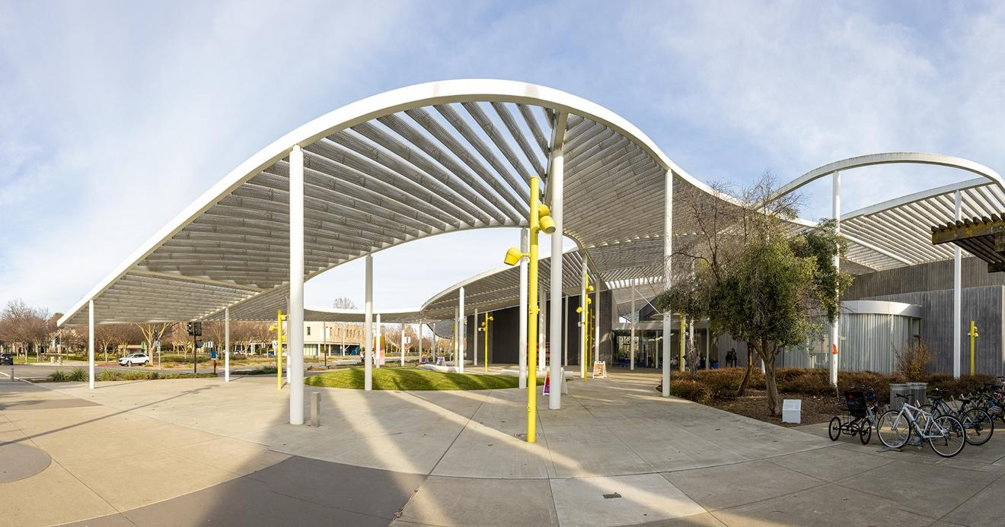
Figure 1: The Manetti Shrem Museum of Art will celebrate its 10-year anniversary in the coming year with special exhibitions and events. Hung Q. Pham Photography

Manetti Shrem Museum’s 10th Year Will Focus on Expanding Access to World-Class Art

Anniversary Year to Feature Woody De Othello in Only California Venue; Kota Ezawa; Digitization Project; New Campus Sculpture
June 15, 2026 – The Jan Shrem and Maria Manetti Shrem Museum of Art at University of California, Davis, will celebrate its 10th anniversary through a yearlong series of special exhibitions featuring new works, events and initiatives that look to the museum’s future and engage both visitors and the university community.
The contemporary art museum opened on Nov. 13, 2016, with a vision of connecting art, people and ideas through transformational art experiences. Its inaugural 2016 exhibition, Out Our Way, explored the development of the UC Davis Department of Art, founded in 1958, whose first generation of faculty comprise both internationally recognized and recently rediscovered artists.
Ten years later, Together Again, 1956-2026: Perspectives from UC Davis’ Fine Arts Collection opens Aug. 26. It is the first presentation of the museum’s newly established ongoing collection galleries. Bringing renowned UC Davis artists into dialogue with overlooked figures and rising stars, the exhibition reflects a collection originally established by faculty artists that has evolved since 2016 to trace a more expansive, place-based history of art. Approximately 70% of the works shown in Together Again represent new acquisitions during the museum’s first decade.
“We look forward to sharing the many ways in which our future is inspired by our past throughout this anniversary year,” said Founding Director Rachel Teagle. “The Together Again galleries celebrate a transformed Fine Arts Collection with important new additions and affirm the Manetti Shrem Museum as home to the complex story of Northern California art — rich in legacy and always in the process of becoming.”
First exhibition opens Aug. 12
Woody De Othello: coming forth by day, a solo exhibition, originated by Pérez Art Museum Miami or PAMM, features a new series of works by the Oakland artist that explore the primordial relationship between body, earth and spirit. Othello honors an important Northern California lineage of ceramic artists and expands that tradition by drawing on knowledge and philosophies from around the world through a decolonial lens. Using material experimentation and sculptural gesture, the exhibition considers how objects carry history, absorb meaning and serve as vessels for both spiritual and emotional experience. The Manetti Shrem Museum is the only California venue for coming forth by day. (August 12–Dec. 5.)

UC Davis legacy
A third fall exhibition, Out of Line: Art at the Edge, explores Davis as a site of both artistic practice and political protest during the 1960s, ‘70s, and ’80s. Inspired by conceptual artist and alum Bruce Nauman’s video work Dance or Exercise on the Perimeter of a Square (Square Dance), 1967–68, this exhibition investigates the boundaries of the artist studio. Artists with ties to UC Davis — including Mike Henderson and, Malaquías Montoya, professors emeriti; Ester Hernandez, Bruce Nauman, Dorothy Wiley, and the students of UC Davis’ Third World Forum — engage with film, print and performance to confront who they were and what their work meant in a world of radical change. (Aug. 25–Dec. 5.)

New public sculpture, digital access
The bronze sculpture one becomes two, two becomes one by Othello — the first new public artwork created specifically for the UC Davis campus in more than 30 years — will be celebrated in spring as the museum’s gift to UC Davis to mark its 10th anniversary. Placed at a campus crossroads near UC Davis Library, the sculpture reaffirms the role of art as a vital presence in campus.

The Manetti Shrem Museum, in a first-of-its kind partnership with UC Davis Library, is expanding public access to the Fine Arts Collection through a major digitization project launching in November. By making the collection searchable through a website that can be accessed directly and through the library’s search function, it will be available for the first time to researchers, students and art lovers.

Career survey debuts ambitious new work
The first career survey of Oakland artist Kota Ezawa, spanning 20 years of art making across video, projection, 16mm film and lightboxes, opens in January. Kota Ezawa: Long Story Short also debuts an ambitious new animation, Acts of Painting, in his unmistakable style visually transforming imagery mined from news media, photography, film, popular culture and the history of art. This survey is the Manetti Shrem Museum’s signature exhibition for the inaugural Further Triennial, a celebration of art across Northern California. (January–May)
Anniversary events for the UC Davis community, longtime supporters and more include a gala celebration (Nov. 14); 10th birthday bash (Jan. 28); Further Triennial’s regional Spotlight Saturday (April 10); and the public dedication of one becomes two, two becomes one (May 6).
More information about the museum’s 10th anniversary exhibitions and events will be announced in late summer.

Support
Presenting support for one becomes two, two becomes one and Woody De Othello: coming forth by day, is provided by Maria Manetti Shrem. Major support is provided by Lorna Meyer Calas and Dennis Calas, Kellie and Jeff Hepper, Carol and Gerry Parker, Jane Rosenberg, and Gina and John Wasson. Generous support is provided by Nancy Roe. The digitization initiative is made possible through the generous support of Carol and Gerry Parker through the Parker Family Digitization Fund.
Visitor Information
Jan Shrem and Maria Manetti Shrem Museum of Art
254 Old Davis Road, Davis, Calif.
Hours: 10 a.m.–5 p.m. Wednesday–Saturday
Admission is Free for All.

Art Wide Open
The Jan Shrem and Maria Manetti Shrem Museum of Art is a contemporary art museum for today, committed to honoring the past and shaping the future while making art accessible and approachable for all. It builds on UC Davis’ legacy of exceptional teaching and practice of the arts to offer engaging experiences, exhibitions and educational programs that reflect and serve the community. One-third of the museum’s 30,000-square-foot space is devoted to instruction, including a lecture hall, classroom space and the drop-in Carol and Gerry Parker Art Studio. Opened in November 2016, the museum has earned numerous architectural honors, including being named one of the 25 Best Museum Buildings of the Past 100 Years by ARTnews.
Media contact & images
Laura Compton, Communications Director, Jan Shrem and Maria Manetti Shrem Museum of Art, llcompton@ucdavis.edu. Publicity photos are available upon request.

